**NAME** :- Manish Shashikant Jadhav

**UID** :- 2023301005.

**BRANCH** :- Comps -B. **BATCH:** B.

**EXPERIMENT 4:**

**SUBJECT** :- DBMS (DATABASE MANAGEMENT SYSTEM)

**TOPIC NO.1: Perform the date operation on given date and write the output:**

1. **curdate():**

select curdate();

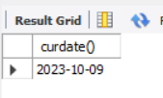

1. **currentdate():**

select current_date();

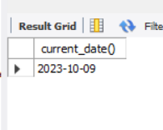

1. **sysdate():**

select sysdate();

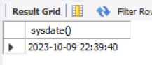

1. **now():**

select now();

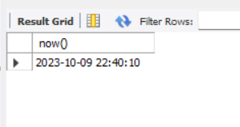

1. **day:**

select day("2023-10-3 09:15:21");

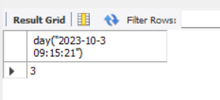

1. **dayname:**

select dayname("2023-10-3 09:15:21");

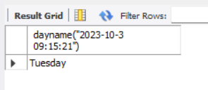

1. **dayofmonth:**

select dayofmonth("2023-10-3 09:15:21");

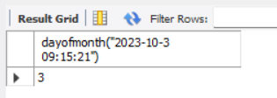

1. **dayofweek:**

select dayofweek("2023-10-3 09:15:21");

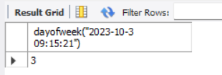

1. **weekday:**

select weekday("2023-10-3 09:15:21");

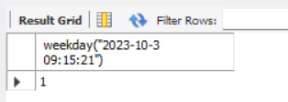

1. **year:**

select year("2023-10-3 09:15:21");



1. **extract function for date, extract the month,year,seconds,minutes,hour,day,week,**

**month,quarter:**

select extract(month from("2023-10-3"))as date;

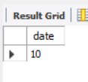

select extract(year from("2023-10-3"))as date;

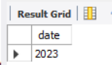

select extract(day from("2023-10-3"))as date;

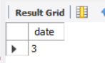

select dayofmonth("2023-10-3");

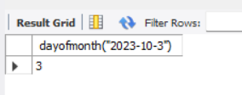

select extract(second from("2023-10-3 09:15:21"))as date;

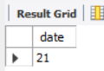

select extract(minute from("2023-10-3 09:15:21"))as date;

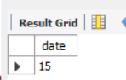

select extract(hour from("2023-10-3 09:15:21"))as date;

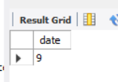

select extract(quarter from("2023-10-3 09:15:21"))as date;

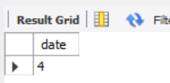

1. **Use adddate and subdate function:**

select adddate("2023-10-3", interval 10 day);

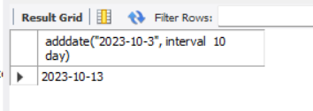

select subdate("2023-10-03", interval 10 day);

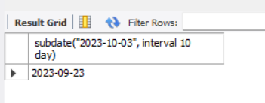

**TOPIC NO. 2: Use following arithmetic functions:**

1. **PI():**

select pi();

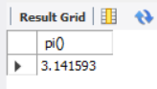

1. **Round():**

select round(2.5);

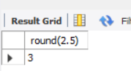

1. **CEIL():**

select ceil(2.5);

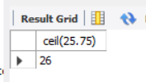

1. **Floor():**

select floor(2.5);

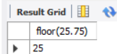

1. **Pow():**

select pow(2,9);

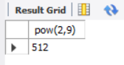

1. **SQRT():**

select sqrt(28);

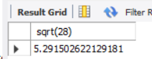

1. **RAND():**

select rand();

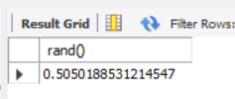

1. **ABS():**

select abs(-28.9);

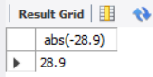

1. **SIGN():**

select sign(289.13);

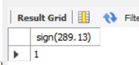

select sign(-289.13);

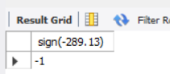

select sign(0);

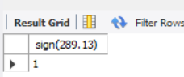

1. **MOD():**

select mod(3,9);

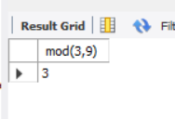

select mod(3,9) as remainder;

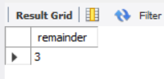

**TOPIC NO 3: Create EMP ( id, lname,fname,title,deptno , salary) table and insert 10 values in it and perform following queries on it.**

1. **Write a SQL query and show the resulting table of salaries if all warehouse manager were given  a Rs. 250 per month raise.**

update EMP set salary = salary + 250 where title="Manager";

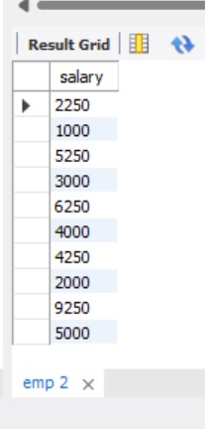

1. **Write a SQL query and show the resulting table to display the amount each warehouse manager currently makes in a year and how much  each one would make in a year with the Rs.250 per month raise. name the new column appropriately.**

update EMP set annual_income= (salary)*12;

